**Delhi**

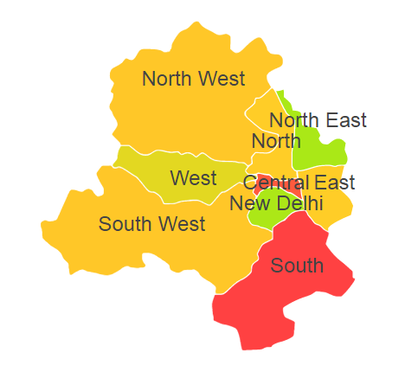

Delhi comprises of one Agro Ecological Region (AER) namely 4.

**Agro-Eco Region 4:** AER 4 in Delhi comprises of Central Delhi, East Delhi, North Delhi, North West Delhi, South Delhi, South West Delhi and West Delhi districts of Northern Plain and Central Highlands including Aravallis under Agro Ecological Sub Regions (AESR) 4.1.